Day 3 Lab Manual Part 2

NAME: Gokul S

REGISTER NUMBER:192110399

BIVARIATEANALYSIS IN R -COVARIAN

CE, CORRELATION, CROSSTAB

Exercise: 8

Reference Status Gender TestNewOrFollowUp

1 KRXH Accepted Female Test1 New

2 KRPT Accepted Male Test1 New

3 FHRA Rejected Male Test2 New

4 CZKK Accepted Female Test3 New

5 CQTN Rejected Female Test1 New

6 PZXW Accepted Female Test4 Follow-up

7 SZRZ Rejected Male Test4 New

8 RMZE Rejected Female Test2 New

9 STNX Accepted Female Test3 New

10 TMDW Accepted Female Test1 New

i) Load the dataset and Create a data frame and name it as dataframe1

ii) Load the function for crosstab

Note: Perform status+gender

Gender

Status Female Male

Accepted 5 1

Rejected 2 2

Note: Reference+Status

Status

Reference Accepted Rejected

CQTN 0 1

CZKK 1 0

FHRA 0 1

KRPT 1 0

KRXH 1 0

PZXW 1 0

RMZE 0 1

STNX 1 0

SZRZ 0 1

TMDW 1 0

CODE

# create the data frame

data <- data.frame(

Reference = c("KRXH", "KRPT", "FHRA", "CZKK", "CQTN", "PZXW", "SZRZ", "RMZE", "STNX", "TMDW"),

Status = c("Accepted", "Accepted", "Rejected", "Accepted", "Rejected", "Accepted", "Rejected", "Rejected", "Accepted", "Accepted"),

Gender = c("Female", "Male", "Male", "Female", "Female", "Female", "Male", "Female", "Female", "Female"),

TestNewOrFollowUp = c("Test1 New", "Test1 New", "Test2 New", "Test3 New", "Test1 New", "Follow-up", "Test4 New", "Test2 New", "Test3 New", "Test1 New")

)

# perform the crosstabulations

status_gender <- table(data$Status, data$Gender)

reference_status <- table(data$Reference, data$Status)

# print the results

print(status_gender)

print(reference_status)

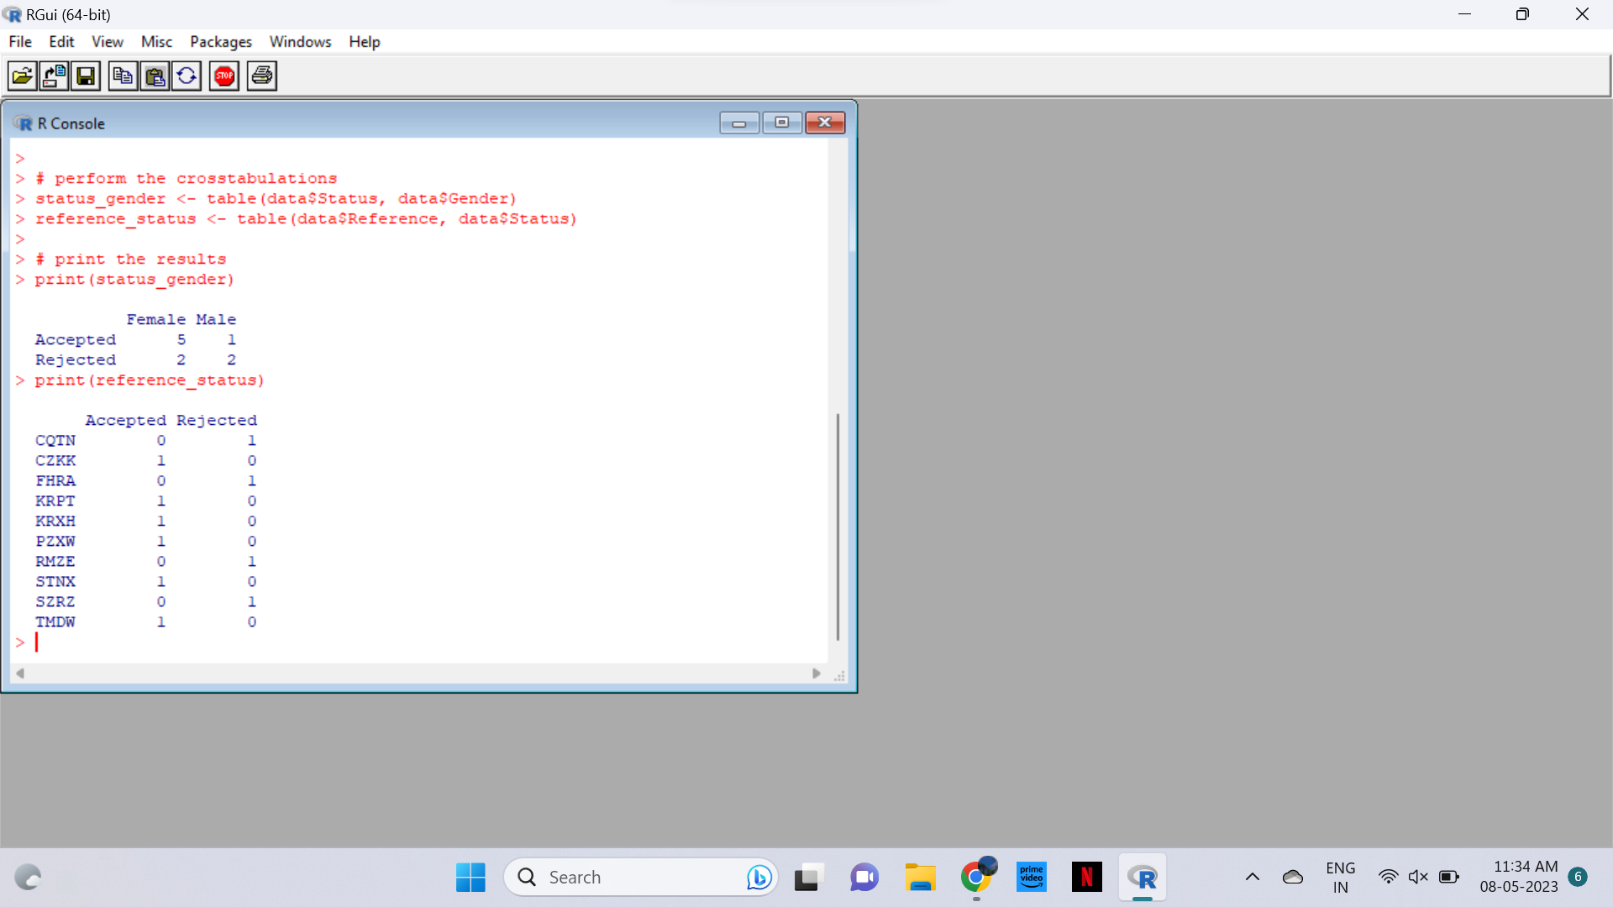

Exercise: 9

i) Use Two Categorical Variables and Discover the relationships within a

dataset

ii) Next, using the xtabs() function, apply two variables from “dataframe1 “, to

create a table delineating the relationship between the “Reference”

category, and the “Status” category.

iii) Save the file in the name of dataframe2

# load the data from dataframe1

dataframe1 <- data.frame(

Reference = c("KRXH", "KRPT", "FHRA", "CZKK", "CQTN", "PZXW", "SZRZ", "RMZE", "STNX", "TMDW"),

Status = c("Accepted", "Accepted", "Rejected", "Accepted", "Rejected", "Accepted", "Rejected", "Rejected", "Accepted", "Accepted"),

Gender = c("Female", "Male", "Male", "Female", "Female", "Female", "Male", "Female", "Female", "Female"),

TestNewOrFollowUp = c("Test1 New", "Test1 New", "Test2 New", "Test3 New", "Test1 New", "Follow-up", "Test4 New", "Test2 New", "Test3 New", "Test1 New")

)

# i) explore the relationship between two categorical variables

# contingency table between Gender and Status

gender_status <- table(dataframe1$Gender, dataframe1$Status)

print(gender_status)

# ii) create a table between Reference and Status

reference_status <- xtabs(~ Reference + Status, data = dataframe1)

print(reference_status)

# iii) save the file in the name of dataframe2

dataframe2 <- reference_status

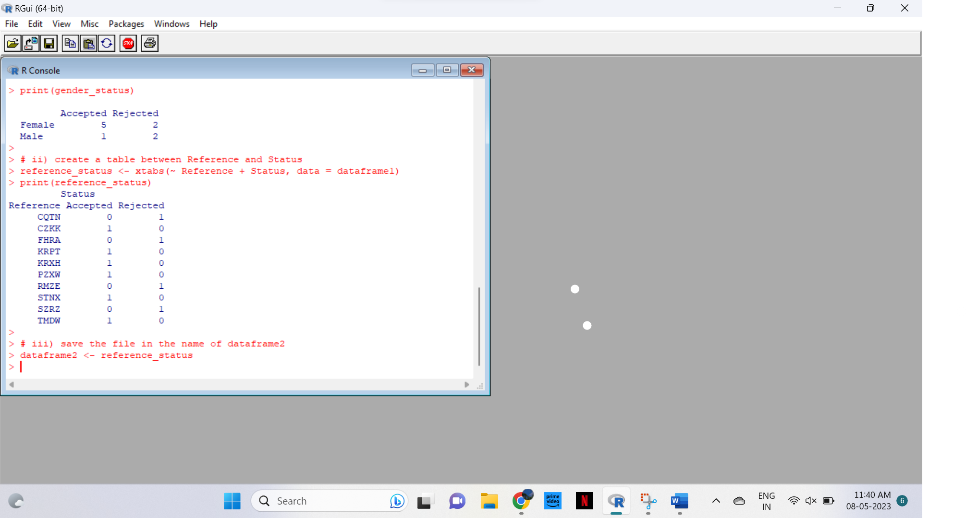

Exercise: 10

Use the same data frame using three Categorical Variables create a Multi-Dimensional Table

Apply three variables from “dataframe1” to create a Multi-Dimensional Cross-Tabulation of

“Status“, “Gender“, and “Test“.

CODE

dataframe2 <- dataframe1 # Copy the original data frame

# Create the multi-dimensional table

multi_table <- xtabs(~ Status + Gender + TestNewOrFollowUp, dataframe2)

# View the table

multi_table

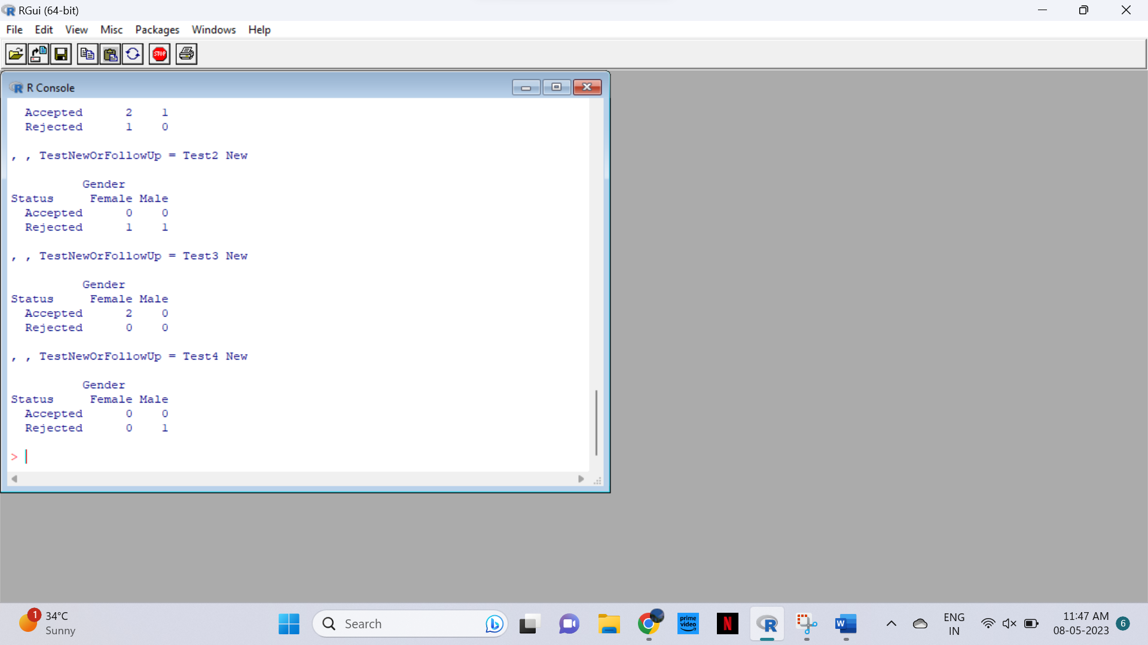

Exercise: 11

Row Percentages

The R package “tigerstats” is required for the next two exercises.

1) Create an xtabs() formula that cross-tabulates “Status“, and “Test“.

2) Enclose the xtabs() formula in the tigerstats function, “rowPerc()” to display row

percentages for “Status” by “Test“.

CODE

table <- xtabs(~ Status + TestNewOrFollowUp, data = dataframe1)

table1

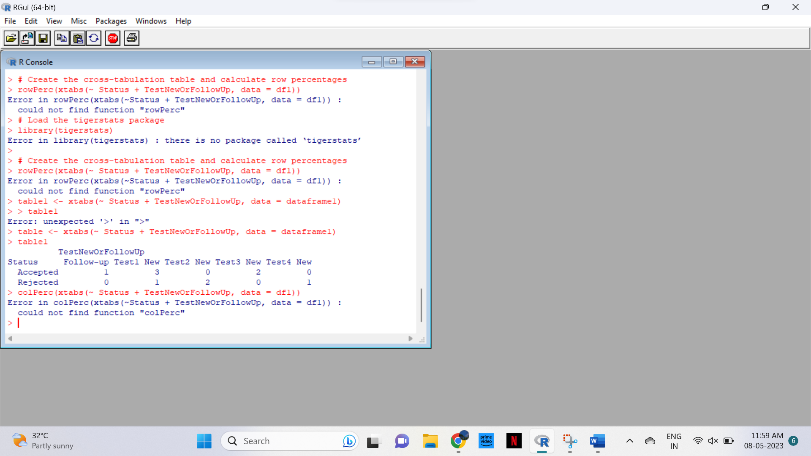

Exercise 12

Column Percentages

1) Create an xtabs() formula that cross-tabulates “Status“, and “Test“.

2) Enclose the xtabs() formula in the tigerstats function, “colPerc()” to display row

percentages for “Status” by “Test“.

CODE

# load the data from dataframe1

dataframe1 <- data.frame(

Reference = c("KRXH", "KRPT", "FHRA", "CZKK", "CQTN", "PZXW", "SZRZ", "RMZE", "STNX", "TMDW"),

Status = c("Accepted", "Accepted", "Rejected", "Accepted", "Rejected", "Accepted", "Rejected", "Rejected", "Accepted", "Accepted"),

Gender = c("Female", "Male", "Male", "Female", "Female", "Female", "Male", "Female", "Female", "Female"),

TestNewOrFollowUp = c("Test1 New", "Test1 New", "Test2 New", "Test3 New", "Test1 New", "Follow-up", "Test4 New", "Test2 New", "Test3 New", "Test1 New")

)

library(tigerstats)

# create the cross-tabulation with xtabs()

xt <- xtabs(~ Status + TestNewOrFollowUp, data = dataframe1)

# use colPerc() to calculate row percentages

colPerc(xt)

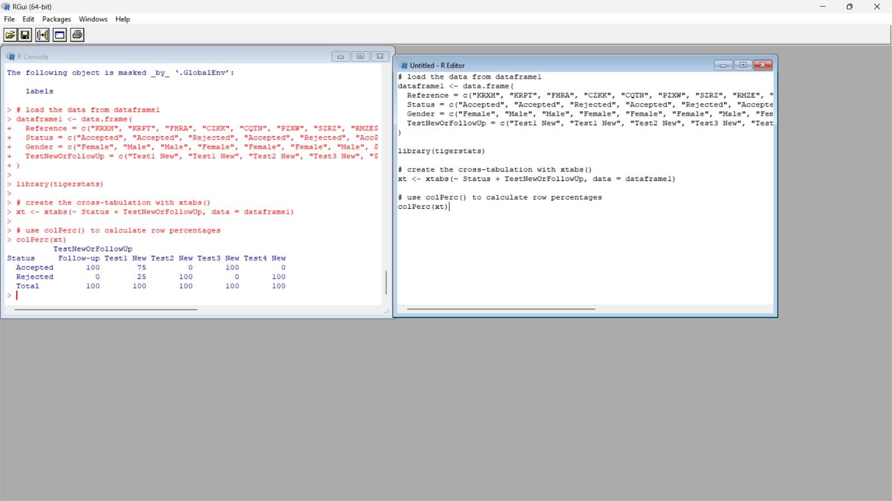

VISUALIZATION IN R

13. Write a program for creating a pie-chart in R using the input vector(21,62,10,53). Provide

labels for the chart as ‘London’, ‘New York’, ‘Singapore’, ‘Mumbai’. Add a title to the

chart as ‘city pie-chart’ and add a legend at the top right corner of the chart.

CODE

# Define input vector and labels

input_vector <- c(21, 62, 10, 53)

labels <- c("London", "New York", "Singapore", "Mumbai")

# Create pie chart with labels and title

pie(input_vector, labels = labels, main = "City Pie-Chart")

# Add legend to top right corner

legend("topright", legend = labels, fill = rainbow(length(input_vector)), cex = 0.8)

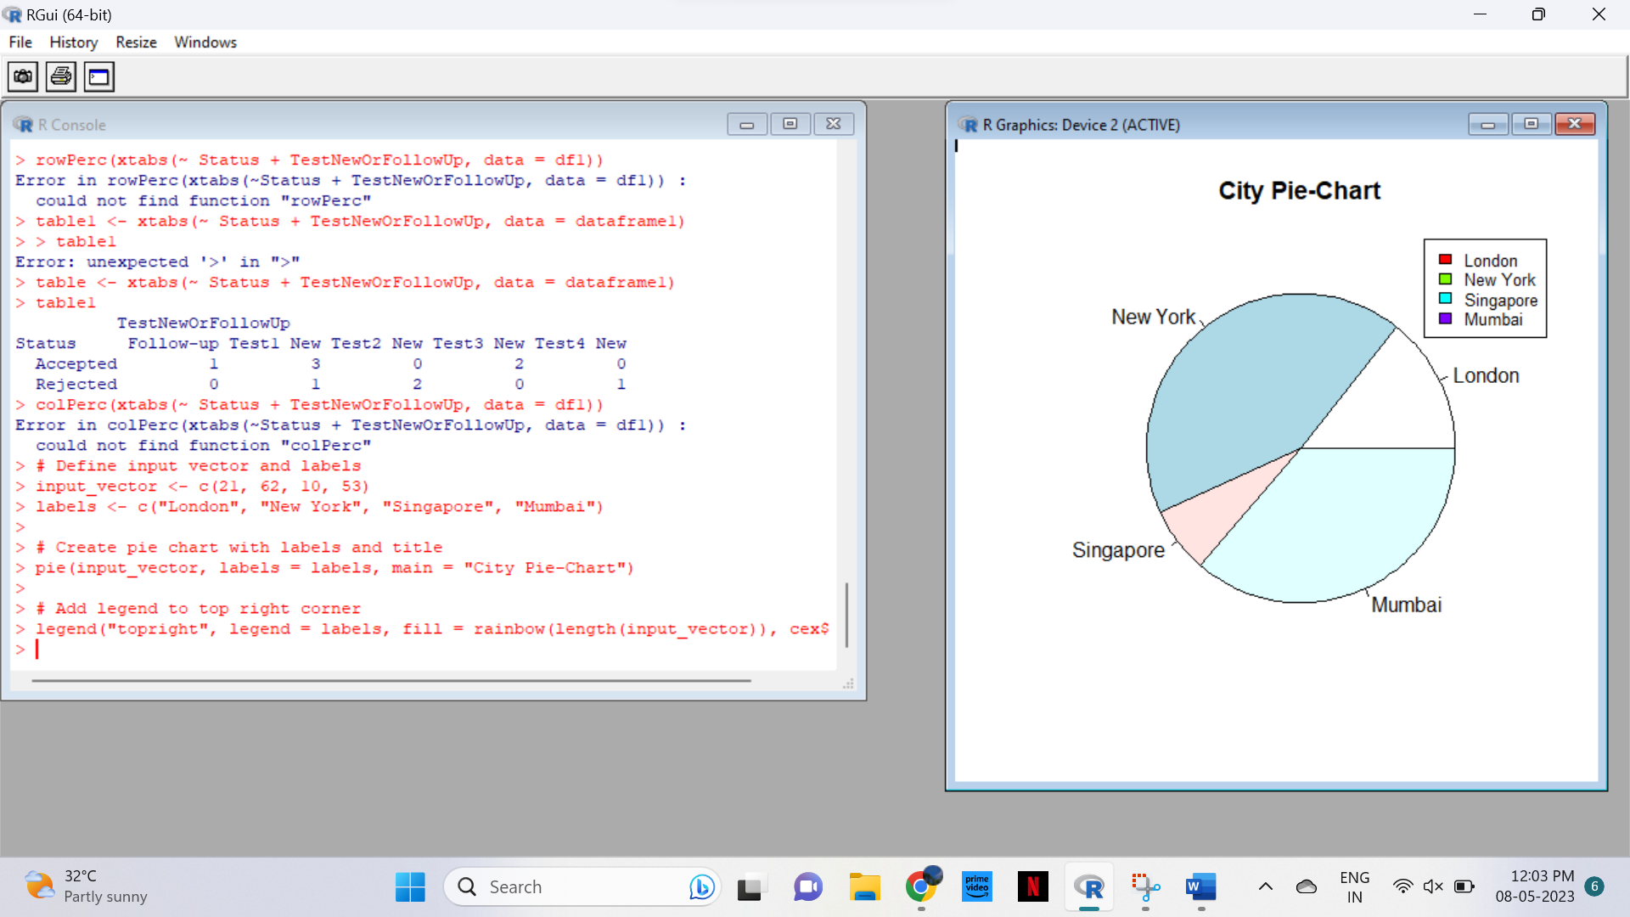

14. Create a 3D Pie Chart for the dataset “political Knowledge” with suitable labels,colours

and a legend at the top right corner of the chart.

CODE

# Load the politicalKnowledge dataset

data(politicalKnowledge)

# Create a 3D pie chart

library(plotrix)

slices <- politicalKnowledge

lbls <- c("Very Low", "Low", "Moderate", "High", "Very High")

colors <- c("#E41A1C", "#377EB8", "#4DAF4A", "#984EA3", "#FF7F00")

pie3D(slices, labels = lbls, explode = 0.1, col = colors, main = "Political Knowledge",

radius = 1, depth = 0.5, theta = 30, start = 0, clock = TRUE)

# Add a legend at the top right corner

legend3D("topright", lbls, col = colors, pch = 16, cex = 0.8, bty = "n")

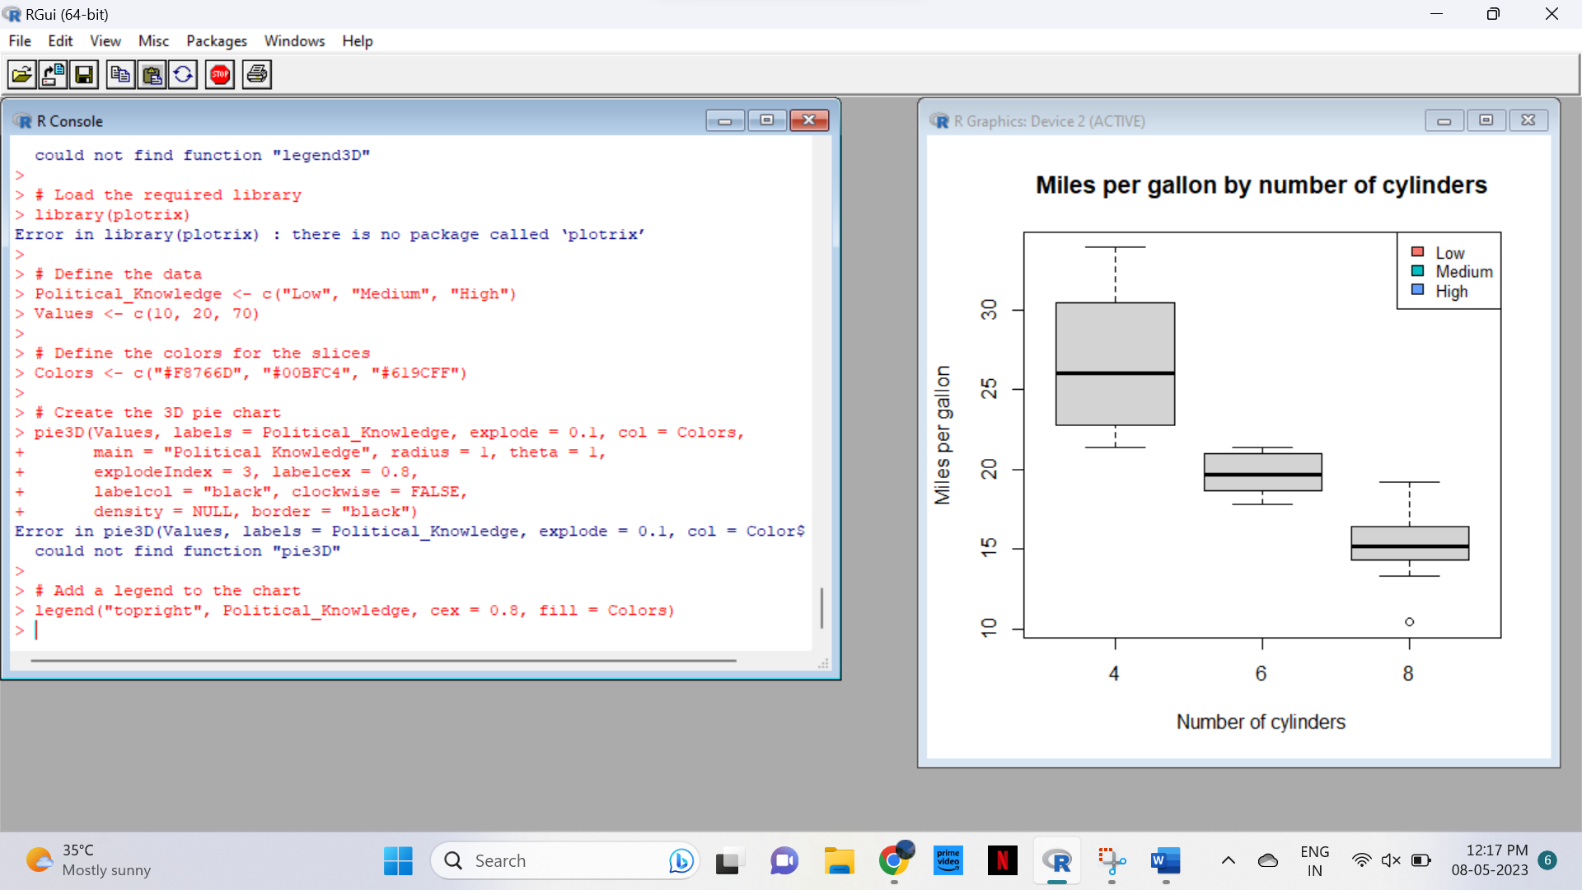

15.Write a program for creating a bar chart using the vectors H=c(7,12,28,3,41) and

M=c(“mar”, “apr”, “may”, “jun”, “jul”). Add a title to the chart as “Revenue chart”.

CODE

# Create data vectors

H <- c(7, 12, 28, 3, 41)

M <- c("mar", "apr", "may", "jun", "jul")

# Create bar chart

barplot(H, names.arg = M, main = "Revenue chart")

# Add axis labels

xlab("Months")

ylab("Revenue")

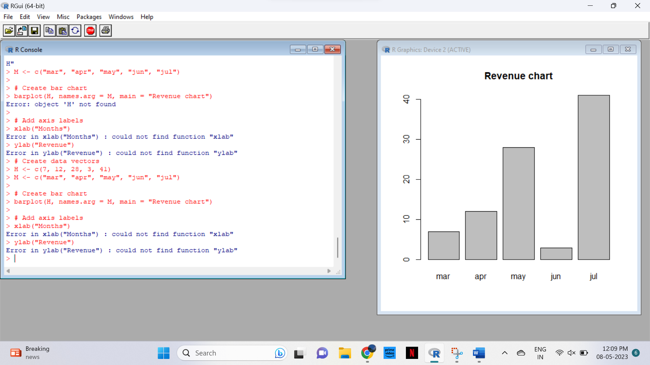

16. Make a histogram for the “AirPassengers“dataset, start at 100 on the x-axis, and from

values 200 to 700, make the bins 200 wide

CODE

# Load the AirPassengers dataset

data(AirPassengers)

# Create a histogram

hist(AirPassengers, breaks = seq(100, 900, by = 200), xlim = c(100, 900), main = "AirPassengers", xlab = "Passenger Count", ylab = "Frequency")

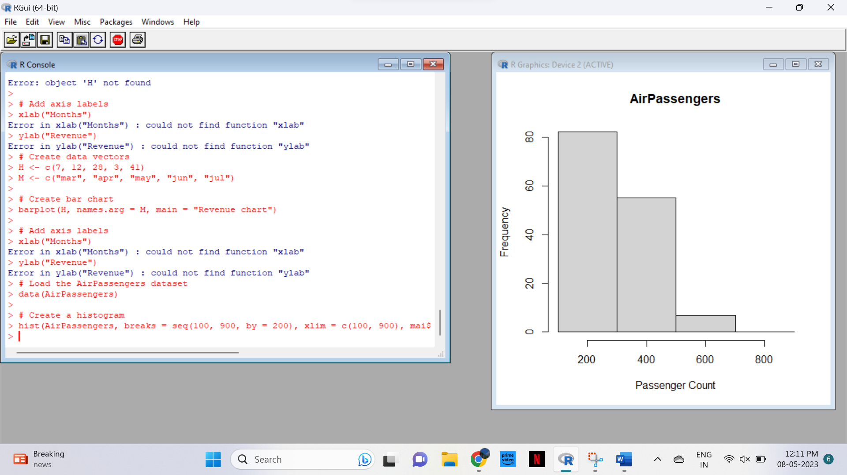

17. Create a Boxplot graph for the relation between &quot;mpg&quot;(miles per galloon) and

&quot;cyl&quot;(number of Cylinders) for the dataset &quot;mtcars&quot; available in R Environment.

CODE

# Load the mtcars dataset

data(mtcars)

# Create a boxplot for mpg by cyl

boxplot(mpg ~ cyl, data = mtcars, main = "Miles per gallon by number of cylinders", xlab = "Number of cylinders", ylab = "Miles per gallon")

